SUMMER INTERNSHIP REPORT

**PRATT MULLER DISTRIBUTORS LTD**

***SUBMITTED BY-***

**Bhanupratap Maurya**

**210280102011**

**UNDER THE GUIDANCE OF-**

**Mr. Yogesh Barot**

**(FOUNDER)**

**(ASSISTANT PROFESSOR IN AUTOMOBILE DEPARTMENT)**

## IN PARTIAL FULFILLMENT FOR THE SUBJECT SUMMER INTERNSHIP (3170001) OF B.E. SEMESTER VII IN AUTOMOBILE ENGINEERING

**SUBMITTED TO-**

**AUTOMOBILE ENGINEERING DEPARTMENT**

 

**LALBHAI DALPATBHAI COLLEGE OF ENGINEERING,**  **AHMEDABAD**

**GUJARAT TECHNOLOGICAL UNIVERSITY**

**YEAR- 2024**

**NO OBJECTION CERTIFICATE (NOC)**

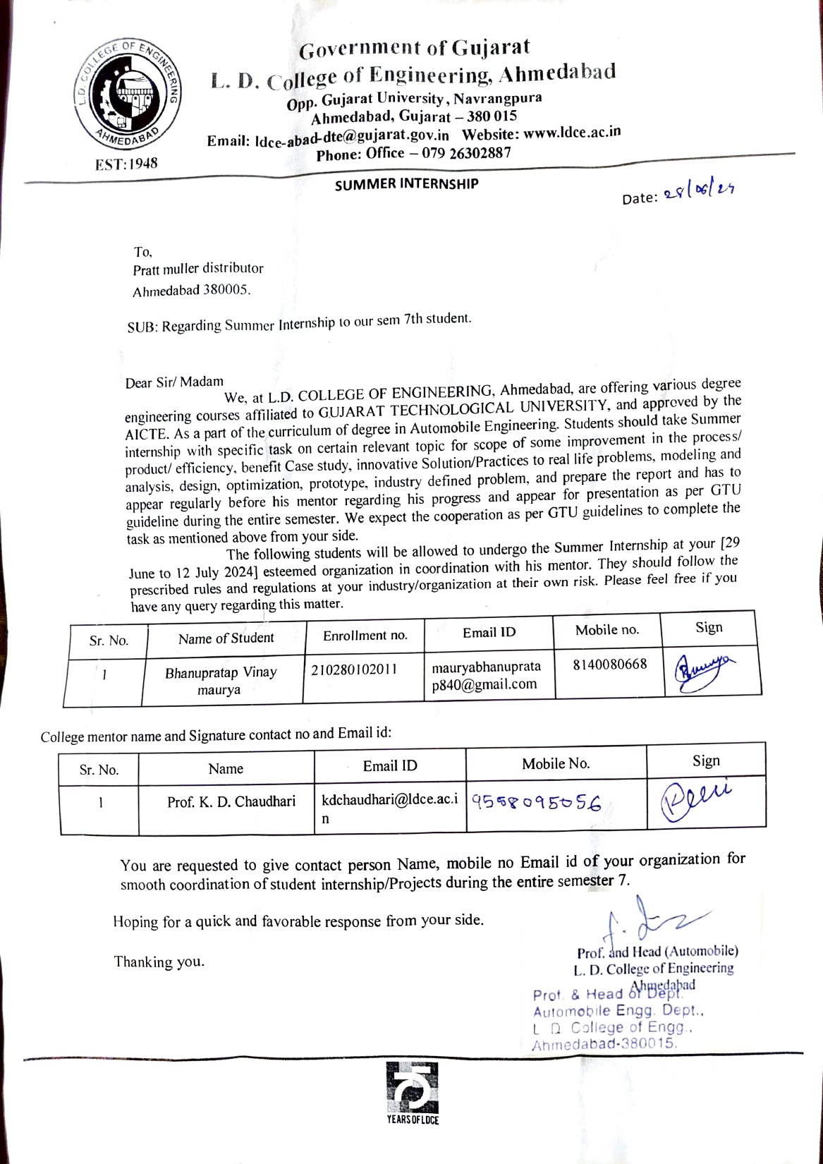

**INTERNSHIP CERTIFICATE**

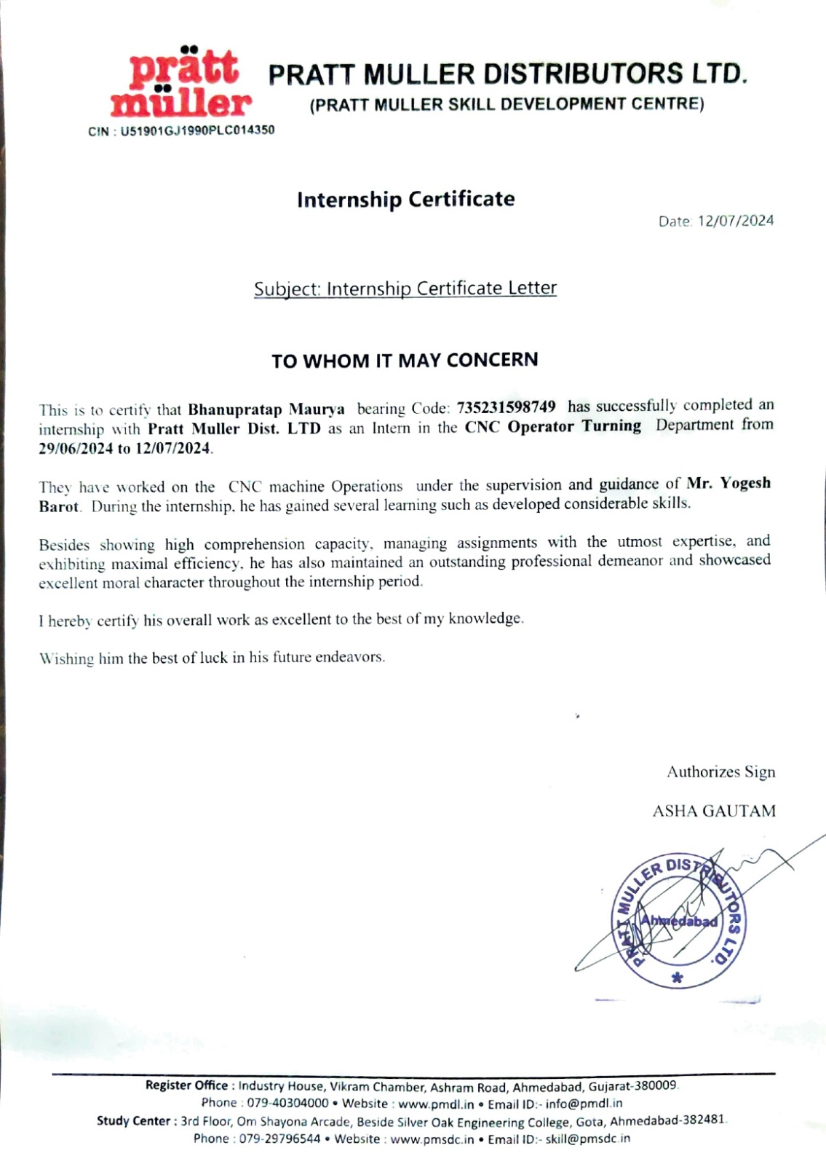

GUJARAT TECHNOLOGICAL UNIVERSITY

## LALBHAI DALPATBHAI COLLEGE OF ENGINEERING

 

CERTIFICATE

This is to certify that the internship report submitted along with the internship titled

**“PRATT MULLER DISTRIBUTORS LTD”** has been carried out successfully by **Bhanupratap Maurya(210280102011)** under my guidance in partial fulfilment for the degree of **Bachelor of Engineering** in **Automobile Engineering 7th semester** of **Gujarat Technological University, Ahmedabad** during the academic year - 2024.

Mr. Kartik D Chaudhary

**Internal Guide Head of the Department**

# ACKNOWLEDGEMENT

I am writing this as an acknowledgement of my gratitude for the valuable opportunity that was provided me by **PRATT MULLER DISTRIBUTORS LTD.** This experience has been incredibly enriching, and I would like to extend my heartful thanks to Mr. Yogesh Barot and the entire team.

Over the course of my internship, I had the privilege to work with them and learn from some of the most talented professionals in the industry. The exposure to real – world projects, hands-on experience and mentorship I received during my time at PRATT MULLER DISTRIBUTORS has been invaluable in enhancing my knowledge and skills in production of Machine parts.

I am truly grateful for the trust and support of my guide **Mr. Kartik D Chaudhary** who had provided best guidance and gave me proper direction.

# ABSTRACT

Automobile engineering is a field where there are new innovations taking place almost every single day. To be in line with these innovations, an aspiring automobile engineer must not only have theoretical knowledge but also the much need practical knowledge.

The education provided by universities focus mostly on theoretical knowledge but it is nothing without any practical knowledge.

Hence, I decided to carry out my 15 days summer internship at “PRATT MULLER DISTRIBUTORS LTD” where the professionals working there provided me with much needed hands-on experience and practical knowledge with visits to various industries and getting familiar with the actual environment of the industry.

This 15-days program consisted of getting familiar with how a Different kind of CNC machine work and the production process of a various metal jobs manufacturing covers almost every aspect of engineering a mechanical/automobile engineer must know.

**Table of Contents**

Acknowledgement…………………………………………………………………………….5

Abstract…………………………………………………………………………………….….6

Table of Contents……………………………………………………………………………...7

**Chapter 1 Introduction……………………………………………………………………...9**

1.1 Objective………………………………………………………………………………9

1.2 Outcome……………………………………………………………………………….9

1.3 Topics Covered………………………………………………………………………..9

**Chapter 2 CNC…………………………………..…………………………………………..10**

2.1 CNC……………………………………………………….………………………….10

2.2 Components of cnc machine…………….………………………..………………..…10

2.3 Types of CNC machine…………….…………………………………………………11

2.4 CNC programming……………………….…………………………………………...11

2.5 Benefits of CNC Programing ………………………………………………………...13

2.6 CNC machining process …………………………………………………...…………14

**Chapter 3 CNC Turning……….** ………..……………………………...…..….…………...**16**

3.1 What is CNC Turning……………….………………………………………………...16

3.2 Components of CNC Turning ………………………………………………………...17

**Chapter 4 VMC** ………………………………………………………………………….....**.20**

4.1 What is VMC machine…………………………………….………………………….20

4.2 Components of VMC machine………………………...…………………………..…22

4.3 Workings of VMC machine ………………………………………..…………………23

* 1. Application of VMC machine……………………………………………………….24

**Conclusion…………………………………………………………………………………….26**

**References……………………………………………………………………………………..27**

# 

# 

# CHAPTER 1: INTRODUCTION

# 

The PRATT MULLER DISTRIBUTORS LTD has precision machined components and assemblies almost all the practical knowledge an engineer must possess.

**1.1 OBJECTIVE**

The main objective of this program is:

* To prepare students for different requirements of the industry
* To guide students for the future industry expectations
* To help students in selecting the interested field for them after giving the overall scenario

**1.2 OUTCOMES**

The outcomes of this program are:

* Understand the basic of shock tube production
* Gain confidence about their interest
* Crack interviews with the basic knowledge
* Understand how to bridge the gap between theoretical and practical knowledge to have an edge over the competition.

**CHAPTER 2: CNC ( Computer Numerical Control)**

1. **CNC :**

Computer Numerical Control is a method used in modern machining to control machine tools via a computer. CNC machine convert a design produced by Computer-aided design (CAD) software into numbers. These numbers can be considered as coordinates of graph and they control the movement of the cutter. It allows for highly precise and complex operations to be performed, which would be difficult or impossible with manual machining.

1. **COMPONENTS OF A CNC MACHINE:**

* **Input devices:**

There include devices like keyboard, punch tapes, or magnetic tapes used to input the programming language

* **Machine Control Unit (MSU):**

This is the heart of the CNC system. It reads the coded instructions, decodes them, and feeds the signal to the axis mechanisms.

* **Drive System:**

This consists of servo motors and amplifiers to move the machine axes as per the instructions.

* **Feedback system:**

Uses sensors and the encoders to monitor the position and speed of the machine axes to ensure accuracy.

* **Display Unit:**

A monitor that shows the program being executed and other relevant data.

1. **TYPES OF CNC MACHINES:**

* **CNC Mills:**

Used foe the milling operations, which involve cutting and shaping

solid materials.

* **CNC Lathes:**

Primarily used for turning operations, involving rotation

of the work piece.

* **CNC Routers:**

Used for cutting and engraving wood, plastic, and other sof

t materials.

* **CNC Plasma cutters:**

Utilized for cutting metals with a plasma torch.

* **CNC Laser cutters :**

Used for cutting materials with a high-power laser.

* **CNC Electrical Discharge Machines (EMD):**

Used for removing material from a workpiece through electrical

discharge (sparks).

1. **CNC PROGRAMING:**

G-code is the most common programming language used in CNC.

It tells The machine where to move, how fast to move , and what path to

follow.

* **G00**: Rapid positioning
* **G01**: Linear interpolation
* **G02**: Circular Interpolation., clockwise
* **G03**: Circular interpolation , counterclockwise
* **M-codes**: Miscellaneous functions (e.g., M03 to start spindle rotation )

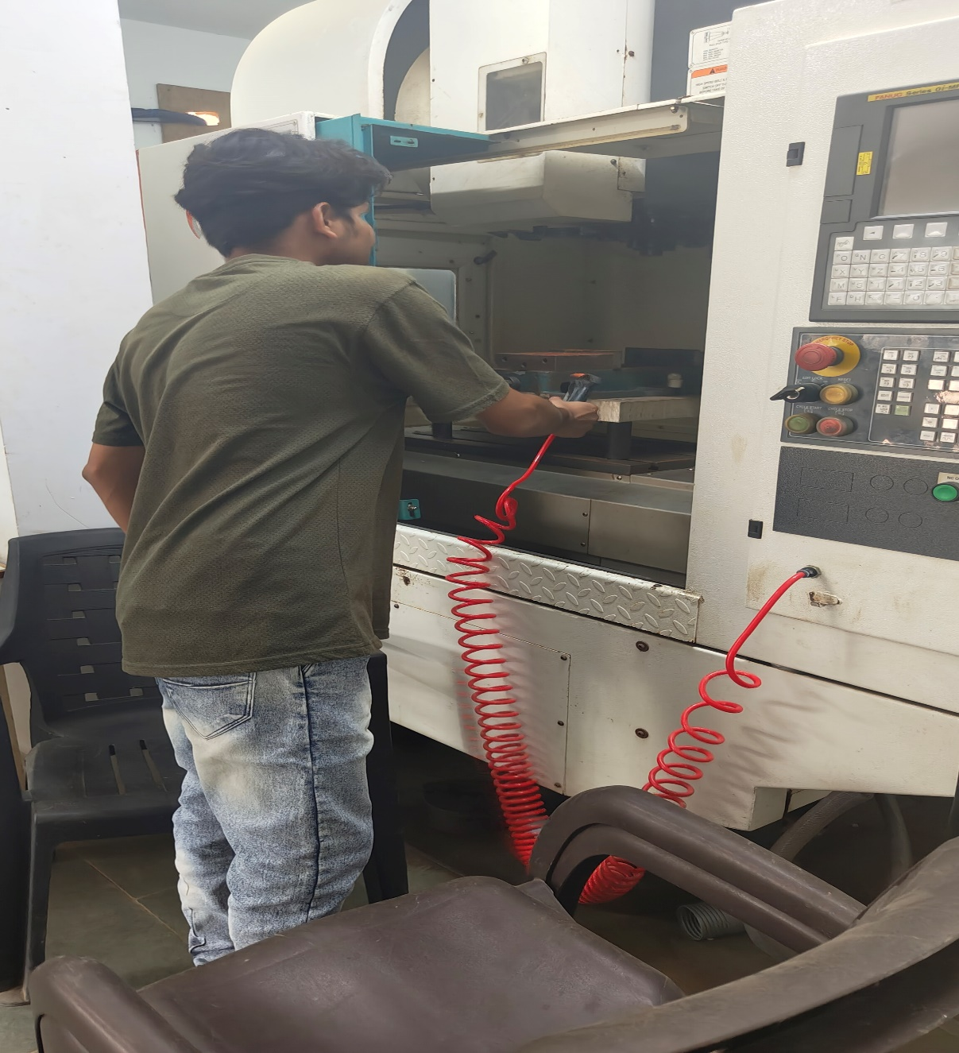

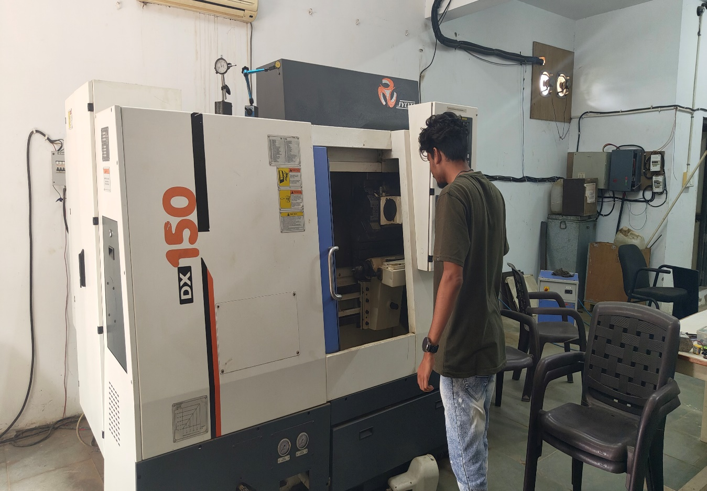

1. **BENEFITS OF CNC MACHINING:**

* **Precision and accuracy:**

CNC machines can achieve very high level of precision.

* **Repeatability:**

They can produce the same part over and with the same

accuracy

* **Complexity:**

Capable of creating complex shapes that are difficult

or impossible to achieve manually.

* **Efficiency:**

Reduce manual intervention and increase productivity.

* **Safety:**

Reduced risk of human error and safer operations.

1. **CNC MACHINING PROCESS**:

* **Design**:

The part is designed using CAD software.

* **Conversion**:

The CAD design is converted into a CNC program using CAM software.

* **Setup**:

The CNC machine is set up with the necessary tools and

Workpieces.

* **Execution**:

The CNC program is loaded, and the machine executes the operations to create the part.

* **Finishing**:

Post-processing operations like debarring, polishing, or additional machining may be required.

1. ***CNC TECHNOLOGY APPLICATION:***

**Aerospace**: precision parts for engines, turbines, and structural

Components.

**Automotive**: Engine components, transmission parts, and custom

Modification.

**Medical**: Surgical instruments, prosthetics, and dental

hospital appliances.

**CHAPTER 3: CNC Turning**

**3.1 What is CNC Turning.**

**Definition**: A CNC turning machine, also known as a CNC lathe, is a type of CNC (Computer Numerical Control) machine specifically designed for turning operations. It is used to shape and cut cylindrical or conical work pieces by rotating them against a stationary cutting tool.

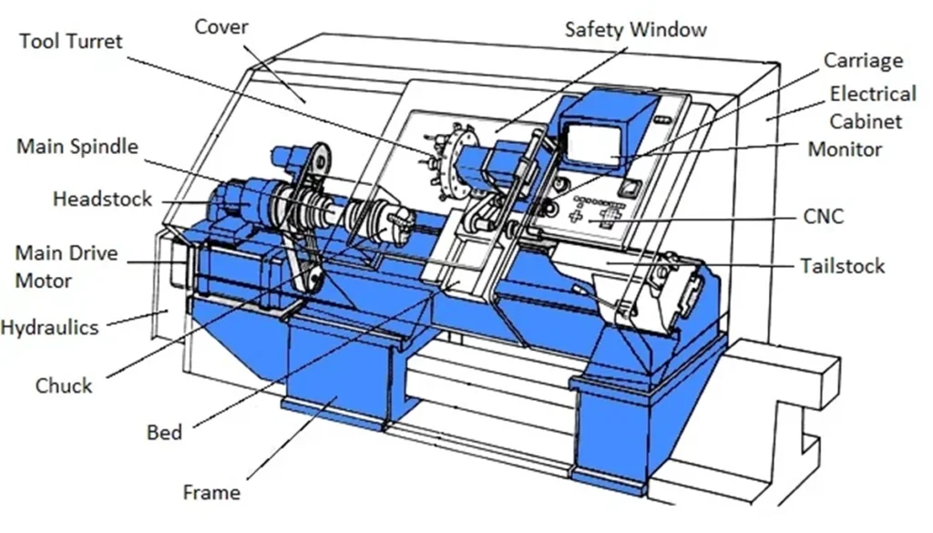

**3.2 Components of CNC Turning.**

• Headstock: Contains the spindle and motor, responsible for rotating the workpiece. It also houses the gears and bearings that support spindle rotation.

• Tailstock: Supports the work piece at the non-driven end, providing stability, especially for longer work pieces. It can be adjusted along the bed to accommodate different work piece lengths.

• Carriage: Moves along the bed and supports the cross slide and tool post.

• Cross Slide: Moves perpendicular to the spindle axis (X-axis), allowing precise control of the cutting tool's position.

• Tool Post: Holds and positions the cutting tools, allowing for quick tool changes and adjustments.

• Bed: The rigid, foundational base of the machine that supports all other components and ensures stability and precision during operation.

• Spindle: The rotating component that holds and drives the work piece. It can vary in speed and direction to suit different machining operations.

•Chuck: The device that grips and secures the workpiece in place. It can be a three-jaw or four-jaw chuck, depending on the shape and requirements of the workpiece.

• Tool Turret: An assembly that holds multiple cutting tools and rotates to bring the appropriate tool into position for each machining operation, allowing for automated tool changes.

• Tailstock Quill: Part of the tailstock that can move in and out to support the workpiece or perform operations like drilling and reaming.

• Feed Mechanism: Controls the movement of the carriage and tool post along the X and Z axes. This includes:

• Lead Screws: Provide precise linear movement.

• Servomotors or Stepper Motors: Drive the lead screws and control the feed rates accurately.

• CNC Controller: The computer system that reads and interprets the CNC program (G-code), controlling the machine’s movements and operations with precision.

• Coolant System: Delivers coolant or lubricant to the cutting area to reduce heat and friction, improving tool life and surface finish.

• Power Supply: Provides electrical power to the machine’s various components, including motors and the CNC controller.

• Safety Guards: Enclosures or shields that protect the operator from moving parts and debris during operation, ensuring a safe working environment.

• Each of these components plays a crucial role in ensuring the CNC turning machine operates efficiently, accurately, and safely.

**CHAPTER 4: VMC(Vertical Machining Technology)**

**4.1 What is VMC Machine?**

Vertical machining technology is one of the most productive tools in the CNC machine shop. It has various tools in the changer and other options that enhance and customize productivity. CNC vertical machining centers are flexible multi-functional tools that help machine holes and other properties in components with a flat surface. It operates in a vertical direction using a spindle that works at a steep angle.

The vertical mills’ computerized controls allow automation, tool selection/rotation, repeatability, and contour control. These modern CNC machines have increased the productivity of the milling machines to the highest level, bringing about the CNC vertical milling centers. These machining centers vary depending on their axes, function, and other options available.

You can refer to the vertical machine center as an industrial workhorse because it can deliver parts with exceptional accuracy and shorter lead times. Its components have robust designs to deliver superior torque, horsepower, and machining speed. The level of automation of vertical milling centers also allows them to cut various materials and reduce overall manufacturing costs.

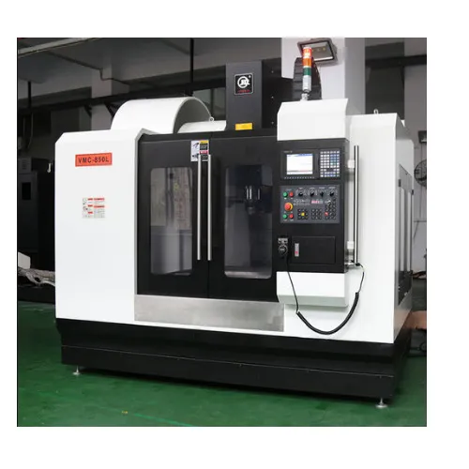

**4.2 Components of VMC Machine**

1. Base The base is the foundational base component of the milling machine. The entire machine is mounted on the base. It is made of rigid materials like cast iron that can support the machine’s weight. Additionally, the base also absorbs the shock generated in the milling operation.

2. Rotating Spindle The milling spindle is usually perpendicular/vertical to the working table. It is a rotating shaft with a unit for holding a tool or work-piece. Generally, the spindle shaft acts as a positioned, support, and rotary drive for work-pieces.

3. Work Table The table is flat on which to put the work-piece directly or using several fixtures such as hard clamping vises or milled aluminium parts. The table has an X-axis which includes the left and right motion, while the Y-axis has a motion to the front and back. These axes and the Z-axis allow you to add unlimited features to work-pieces across the planes of motion.

4. Tool Changer The tool changer increases the productivity of the vertical machine centre by allowing the automatic selection of tools for different tasks ranging from rough cutting to fine-hole boring.

5. Rotating Tables Adding extra axes to the vertical mills can significantly enhance productivity by changing a simple 3- axis milling machine into a 4-axis or 5-axis machine capable of producing complex components with different surfaces like turbine blades.

6. Coolant System Most CNC vertical milling centres use recalculating coolant systems to ensure parts and cutter tools are well lubricated. This coolant system often utilizes water and soluble oil amongst various liquids.

7. Enclosures/Full Covers These covers help to reduce the splatters caused by the milling operations. Likewise, it safeguards the machinists and the environment from the machining operation.

8. Quick Loading Loaders Shuttle tables or other automated part-loading systems help to increase the productivity of the CNC vertical machining centre while reducing downtime.

9. CNC Controller The CNC (Computer Numerical Control) controller is the central component of a VMC (Vertical Machining Center) that manages and directs the machine’s operations. It is responsible for interpreting the CNC program, which contains a set of instructions (G-codes and M-codes) that specify the movement, speed, and other parameters of the machine’s cutting tools.

10. CNC Pendant / Jogger The CNC jogger, also known as a jog control or manual pulse generator (MPG), is a device that allows operators to manually control the movement of the VMC machine’s axes. It is an essential tool for setup, alignment, and testing operations, providing precise and incremental control over the machine’s movements.

11. Screw/Chip Conveyor Chip conveyors or augers can help move chips from the work area to facilitate productivity and eliminate downtime from manually hovelling waste chips.

**4.3 Working of VMC Machine**

Detailed step by step working process for milling machines:

• Part Design: The process starts with the designing of the part to have a clear understanding of what is required. For CNC mills, the design process includes programming and making machine instruction files with CAM software. For manual milling machines, the part design can be a basic blueprint that includes the various dimensions.

• Machine Setup: The milling machine requires a proper setup before the machining starts. This includes adjusting the various settings. For CNC milling machines, the program is transferred to the control system. For manual milling machines, the various parameters of the machine are adjusted as per requirement

• Work-piece Fixture: The work-piece is mounted on the table securely. It is important to ensure that all the fixtures and clamps are tight. Any loose fixtures result in vibrations that can cause poor-quality milling operation or even damage to the parts.

• Milling: The milling process begins after the work-piece is fixed and the machine setup is complete. The rotary cutters remove material from the surface a little at a time. The path and shape of material removal depends on the type of the milling tool and the required shape. The rate of cutting tool movement into the work-piece is called the feed rate.

• Part Inspection: Once the milling cycle completes, the part is removed and inspected for quality. If the quality is up to the required standard, the part is removed and sent for further processing. If it needs further work, the part undergoes another milling pass.

**4.4 Applications of VMC machine**

• Precision Machining :Precision machining activities are primarily found in the defence, energy, and electronics sectors. In this respect, VMCs perform a wide array of challenging tasks involved in high-volume manufacturing, small-batch production, and prototyping. These tools dexterously deal with diversified machining challenges while maintaining high-quality performance and versatility. They can also handle complex and intricate parts with tight tolerances, which is why precision component manufacturers prefer these machining tools so much.

• Fabrication of Medical Devices: Quality and precision are the two strongest pillars of the modern-day medical device-making industry; thus, these two factors cannot be compromised. Here comes the actual role of the vertical machining centre. Complex components like prosthetic devices, surgical instruments, and orthopaedic implants can be dealt with only by these advanced machining tools. Since VMCs can work with different materials, including titanium and stainless steel, they are treated as the most suitable option for fabricating medical devices.

• Automotive Manufacturing: There is no automotive part manufacturing unit today that does not know what is VMC machine. The recent automotive industry has involved extensive VMCs to facilitate the manufacture of auto components like brake systems, chassis parts, transmission components, engine blocks, and others. Due to this tool’s versatility, production processes can be effectively streamlined, maintaining a perfect competitive stand.

**CONCLUSION:**

The internship at the Pratt Muller Dist. provide valuable bearing manufacturing in turning, shaping, finished also knowledge about industries is includes.

• I also learned about various type of materials and various type of bearing and learned about machines. Which is essential for my career in the Automobile Designing Industry.

**REFERENCE:**

<https://en.wikipedia.org/wiki/India>

<https://www.3erp.com/blog/milling-machine/#History-of-Milling-Machines>

<https://openoregon.pressbooks.pub/manufacturingprocesses45>

<https://www.xometry.com/resources/machining>

<https://waykenrm.com>

<https://fractory.com/milling-cutters-and-tools>

<https://www.techniksusa.com/cnc-collets-types-and-maintenance-tips-techniks>

<https://www.fictiv.com/articles>

<https://www.acemicromatic.net/aceproduct/acer-50/#producthighlight>